In this tutorial, we will visit how to create a Chef workstation using ChefDK (Chef Development Kit) for developmental testing. From a workstation, we will use the utility Knife to issue commands to bootstrap Chef nodes, insert them into Chef Server and bind recipes on the nodes and normalize them to our desired state.

If you do not know what Chef is, an overview of Chef can be found here:  
<http://docs.chef.io/chef_overview.html>

**Pre-requisite**

* Have either Chef Server 12 or Hosted Chef installed
* Please visit my Chef Server 12 installation tutorial <http://www.richardyau.com/?p=88>

**1. Install Latest ChefDK from Opscode Website**

ChefDK also know as Chef Development Kit includes all the tools needed to start testing and deploying cookbooks onto test server instances. We shall be installing ChefDK on CentOS 6.x and get our testing environment up and running.

* Download latest RHEL ChefDK from <http://downloads.getchef.com/chef-dk/>
* Run **sudo rpm -Uvh chefdk-0.3.5-1.x86_64.rpm** to install ChefDK (This command installs version 0.3.5)

**2. Set Path to ChefDK Embedded Version of Ruby on CentOS**

We’ve found that the current default Ruby install on yum is 1.8.7 at the moment. So to make things simple, we shall use chefdk’s embedded ruby which contains everything that we need for our ruby environment

* Add the following in your .bash_profile for the user that you are logged in as

*PATH=/opt/chefdk/embedded/bin:${HOME}/.chefdk/gem/ruby/2.1.0/bin:$PATH*

* Log out and log back in for the new path to take effect to take effect
* Execute a **echo $PATH**to see if new PATH has taken hold

**Chef WorkStation Setup if chef-server 11.x**  
**1)** Run the following command that appears (for UNIX and Linux environments):

# curl -L https://www.opscode.com/chef/install.sh | bash

% Total % Received % Xferd Average Speed Time Time Time Current

Dload Upload Total Spent Left Speed

101 6790 101 6790 0 0 3826 0 0:00:01 0:00:01 --:--:-- 12190

Downloading Chef for el...

Installing Chef

warning: /tmp/tmp.KnyQTnqz/chef-.x86_64.rpm: Header V4 DSA/SHA1 Signature, key ID 83ef826a: NOKEY

Preparing... ########################################### [100%]

1:chef ########################################### [100%]

Thank you for installing Chef!

**2)** When the installation is finished enter the *chef-client* command to verify that the chef-client was installed:

# chef-client -v

Chef: 11.6.0

**3)** Create the “.chef” directory  
The .chef directory is used to store three files:

* knife.rb
* ORGANIZATION-validator.pem
* USER.pem

**a)** Copy Cert Keys from Chef Server to your Workstation User Folder:

$ mkdir ~/.chef

$ scp root@chef-server:/etc/chef-server/admin.pem ~/.chef

$ scp root@chef-server:/etc/chef-server/chef-validator.pem ~/.chef

**b)** Now we will configure the Client setting using *knife* command.

$ knife configure -i

Overwrite /root/.chef/knife.rb? (Y/N) y

Please enter the chef server URL: [https://test.example.com:443] https://chef-server.example.com:443/

Please enter a name for the new user: [root] knife-user1

Please enter the existing admin name: [admin] Enter

Please enter the location of the existing admin's private key: [/etc/chef-server/admin.pem] ~/.chef/admin.pem

Please enter the validation clientname: [chef-validator]

Please enter the location of the validation key: [/etc/chef-server/chef-validator.pem] ~/.chef/chef-validator.pem

Please enter the path to a chef repository (or leave blank):

Creating initial API user...

Please enter a password for the new user:

Created user[knife-user1]

Configuration file written to /root/.chef/knife.rb

**c)** Your Knife config file (knife.rb) will look like:

$ cat ~/.chef/knife.rb

log_level :info

log_location STDOUT

node_name 'knife-user1'

client_key '/root/.chef/knife-user1.pem'

validation_client_name 'chef-validator'

validation_key '/root/.chef/admin.pem'

chef_server_url 'https://chef-server.example.com:443/'

syntax_check_cache_path '/root/.chef/syntax_check_cache'

**d)** Verify the install by running the following commands to ensure that every client and user was registered correctly.

$ knife client list

chef-validator

chef-webui

$ knife user list

admin

knife-user1

**Chef WorkStation Setup if chef-server 12.x**

**Create a User and Organization and Download Starter Kit**

* Select download **Download Starter Kit** in Chef Server
* **If you created a starter kit already, do not download the starter kit, it will reset your organization keys**

[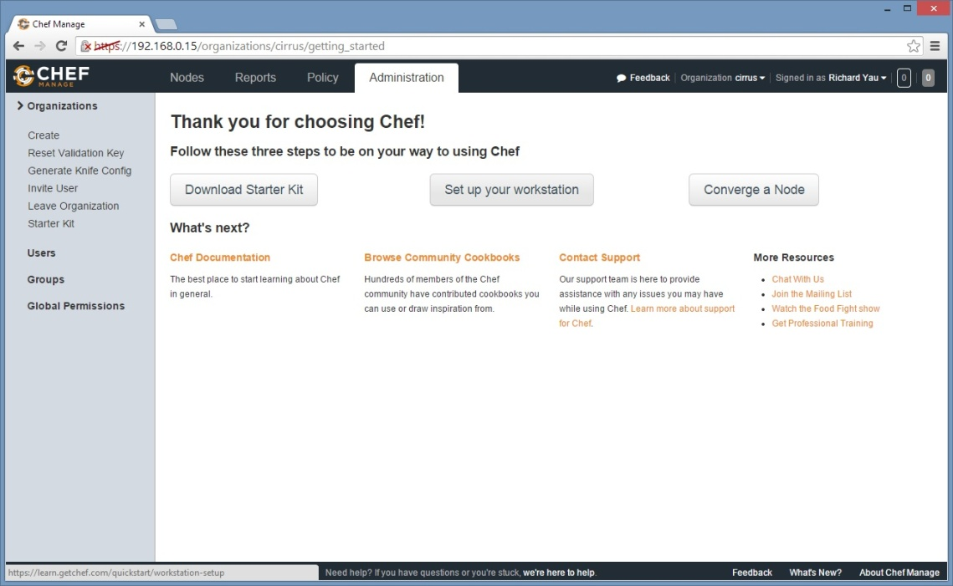](http://www.richardyau.com/wp-content/uploads/2014/12/chefgs.jpg)

* After you click on Download Starter Kit, you will be presented with a **chef-starter.zip** file. Put this file in your home folder on the ChefDK instance and extract it, this will create a ~/chef-repo folder.
* Make sure your Chef Server is resolvable from the ChefDK instance. Add the Chef Server hostname entry to**/etc/hosts**on your ChefDK instance
* Go to ~/chef-repo folder and enter in **knife list environments**to verify if installed correctly. It will. If you have a blank install you should receive the following output

*[root@chefdk chef-repo]# knife list environments*

*environments/_default.json*

* (OPTIONAL) If you want to enable knife commands throughout your system to your chef server, copy the .chef folder in chef-repo to your home .chef folder cp -R ~/chef-repo/.chef ~/

*total 24*

*drwxr-xr-x 3 root root 4096 Dec 16 13:19 .*

*drwxr-xr-x 5 root root 4096 Dec 16 12:58 ..*

*-rw-r--r-- 1 root root  625 Dec 16 12:56 knife.rb*

*-rw-r--r-- 1 root root 1678 Dec 16 12:56 richardyau.pem*

*-rw-r--r-- 1 root root 1678 Dec 16 12:56 chef-validator.pem*

*drwxr-xr-x 2 root root 4096 Dec 16 13:19 trusted_certs*

* Verify the install by running the following commands to ensure that every client and user was registered correctly.

$ knife client list

chef-validator

chef-webui

$ knife user list

admin

knife-user1